Internship

Contents

1. DFD-diagrams: 4

1.1. Level-Zero: 4

1.2. Level-One: 5

1.3. Level-Two: 6

2. Introduction 7

2.1 Overview 7

2.1.1 Features : 7

2.2 Creating JSP File : 7

2.3 Servlet : 8

2.4 DAO : 8

2.5 Bean : 9

3. Prerequisite : 9

3.1 Steps to make Web page with Database : 9

4. Creating Database in MySQL : 9

4.1. Overview 9

4.2. MySQL Queries : 9

4.2.1 Screen Image : 10

4.2.2 Resume Table 11

4.3 DB Connection (for MySQL Database) 11

5. Login Page: 12

5.1. Source image 12

5.1.1 if password is valid: 12

5.1.2. if password is invalid: 13

5.2 Functionalities : 13

5.3 login page code: 13

6. Registration Page : 15

6.1 Source image: 15

6.2 Functionalities : 17

6.3 Register page code: 17

7. Forget Password page : 18

7.1 Source image: 18

7.2 Functionalities : 18

7.3 Register page code: 19

8 .Welcome page : 19

8.1 Source image: 19

8.2 Functionalities : 20

9. Profile page : 20

9.1 Source image: 20

9.2 Profile page code: 20

9.3 Update Profile : 21

9.3.1 Source image: 21

9.3.2 Update page code: 21

10. Resume Builder : 22

10.1 Source image: 22

10.2 Resume Builder Code: 25

11. Resume Updation : 26

11.1 Source image: 26

11.2 Resume Download Codes: 28

12. Contact Us : 29

12.1 Source image: 29

# 1. DFD-diagrams:

## 1.1. Level-Zero:

**Fig:** DFD-level 0

## 1.2. Level-One:

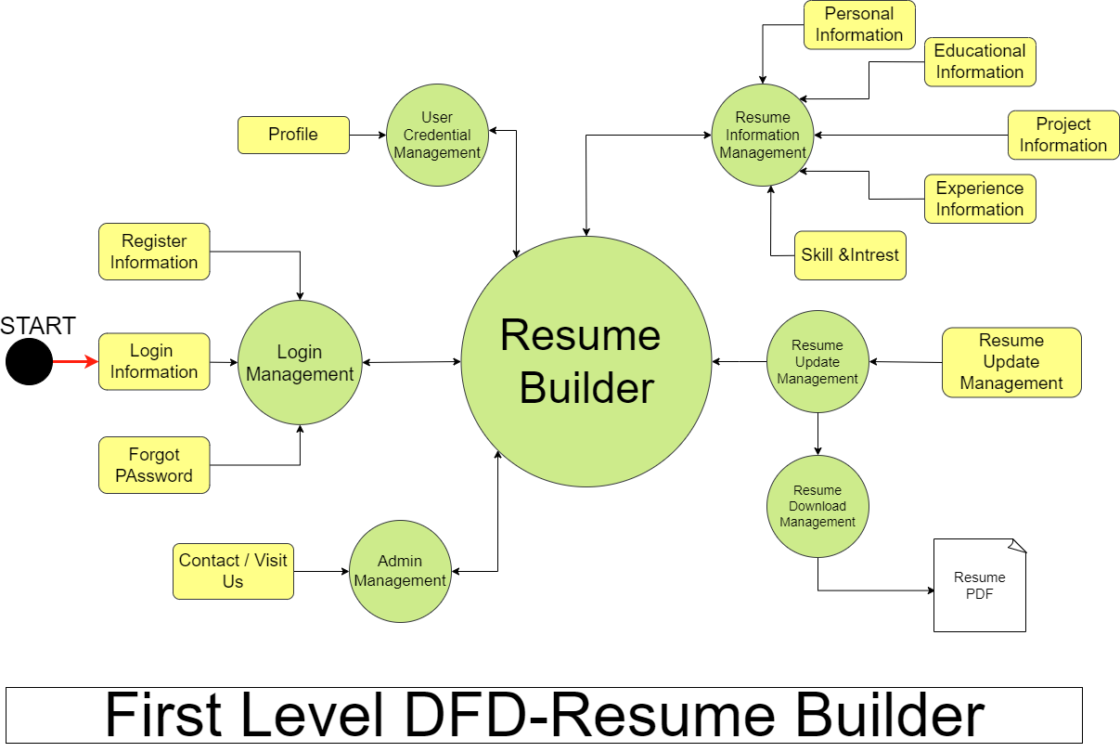 **Fig:** DFD-level 1

## 1.3. Level-Two:

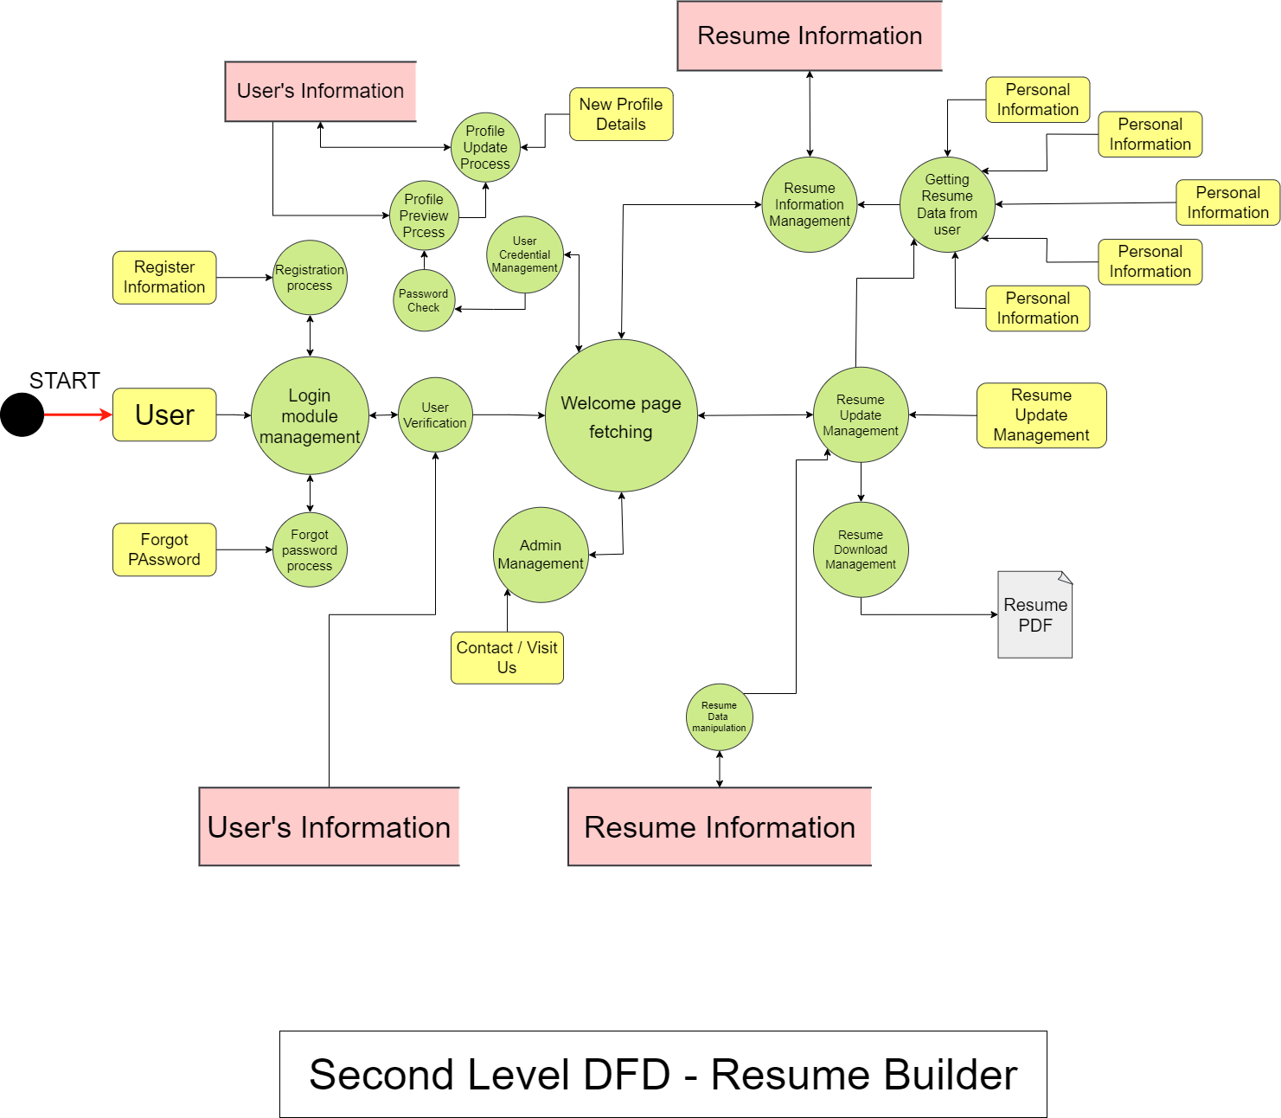**Fig:** DFD-level 2

# 2. Introduction

## 2.1 Overview

This project is user-friendly and requires minimum human intervention. Individuals just have to fill up a form that specifies questions from all required fields such as personal questions, educational, qualities, interest, skills and so on. The answers provided by the users are stored and the system automatically generates a well structured resume. Users have option to create resume in any format and file.

### 2.1.1 Features :

• User login: Users have to create an account into the system by registering themselves. Then they may login into the system and can utilize services.

• Resume form: Users on selecting the format will be given an online form to be filled. The form includes questions like academics, personal, interests, project, skills, courses, experience and so on.

• Resume builder: On submitting the form the system stores the data and within a short period of time generates resume in PDF.

## 2.2 Creating JSP File :

**JSP** technology is used to create web application just like Servlet technology. It can be t hought of as an extension to Servlet because it provides more functionality than servlet such as expression language, JSTL, etc.

**Function List used for JSP and CSS**

|  |  |
| --- | --- |
| **Function name** | **Description** |
| **validateUsN()** | It is an user-defined Java Script function used to validate the User Name by use of Regular Expression. |
| **validateFiN()**  **&**  **validateLiN()** | It is an user-defined Java Script function used to validate the First and Last Name of the user by use of Regular Expression. |
| **validatePass()** | It is an user-defined Java Script function used to validate the pasword of the user by use of Regular Expression. |
| **conPass()** | It is an user-defined Java Script function used to validate the re-pasword by already typed password. |
| **vali()** | It is an user-defined Java Script function used to validate the Email of the user by use of Regular Expression. |
| document.getElementById  (" *elementId* ").value | The value property sets or returns the value of the value attribute of a text field.The value property contains the default value OR the value a user types in (or a value set by a script). |

## 2.3 Servlet :

Java Servlets are programs that run on a Web or Application server and act as a middle layer between a requests coming from a Web browser or other HTTP client and databases or applications on the HTTP server.

Using Servlets, you can collect input from users through web page forms, present records from a database or another source, and create web pages dynamically.

Java Servlets often serve the same purpose as programs implemented using the Common Gateway Interface (CGI). But Servlets offer several advantages in comparison with the CGI.

**Method List used in Servlet :**

|  |  |
| --- | --- |
| **Method name** | **Description** |
| **doPost()** | The doPost() method in servlets is **used to process the HTTP POST requests**. It is used to submit the data from the browser to the server for processing. The data submitted with POST method type is sent in the message body so it is secure and cannot be seen in the URL. |
| **getParameter()** | **Returns the value of a request parameter as a String , or null if the parameter does not exist**. Request parameters are extra information sent with the request. |
| **setAttribute()** | setAttribute() method is **used to set an attribute to a servlet request in a web application**. Attributes set by this method can be reset between requests. This method can be used in Servlet and/or in JSP. |
| **Forward()**  **&**  **Include()** | The forward() method is used to transfer the client request to another resource (HTML file, servlet, jsp etc). When this method is called, the control is transferred to the next resource called. On the other hand, the include() method is used to include the content of the calling file into the called file. |
| **RequestDispatcher** | The RequestDispatcher interface provides the facility of dispatching the request to another resource it may be html, servlet or jsp. This interface can also be used to include the content of another resource also. It is one of the way of servlet collaboration. |

## 2.4 DAO :

DAO is a simple java class which contains JDBC logic . Data Access Layer has proven good in separate business logic layer and persistent layer. The DAO design pattern completely hides the data access implementation from its clients.

 A data access object (DAO) is a pattern that provides an abstract interface to some type of data base or other persistence mechanism . By mapping application calls to the persistence layer, the DAO provides some specific data operations without exposing details of the database. This isolation supports the single responsibility principle. It separates what data access the application needs, in terms of domain-specific objects and data types (the public interface of the DAO), from how these needs can be satisfied with a specific DBMS, database schema, etc. (the implementation of the DAO).

## 2.5 Bean :

JavaBeans are classes that encapsulate many objects into a single object (the bean). It is a java class that should follow following conventions: Must implement Serializable. It should have a public no-arg constructor. All properties in java bean must be private with public getters and setter methods.

# 3. Prerequisite :

* Eclipse IDE for Enterprise Java and Web Developers
* [Apache Tomcat v9.](https://tomcat.apache.org/)0
* [MySQL Workbench](https://dev.mysql.com/downloads/windows/installer/8.0.html)
* [MySQL Connector Java 8.0](https://dev.mysql.com/downloads/connector/j/)

## 3.1 Steps to make Web page with Database :

* Create database table for registration in MySQL with required fields like User Name,Password,Email…ect.,
* Create database table for resume in MySQL with required fields with same username,Email and ect.,
* Write java program for JDBC connection.
* Write java program using servlet classes.
* Create web page for Login and Register page using JSP.
* Give proper control sequence for web page to access Database.
* Create web page for Resume Builder page using JSP.
* Give proper control sequence for web page to access Database.

# 4. Creating Database in MySQL :

## 4.1. Overview

MySQL is a relational database management system based on the Structured Query Language, which is the popular language for accessing and managing the records in the database. MySQL is open-source and free software under the GNU license.

## 4.2. MySQL Queries :

Create Database :

**CREATE** **DATABASE** Database_Name;

Create New table :

* We must declare the Database which we want to use.

**Query :**

**USE** Database_Name;

* Create the Table

**Query :**

**CREATE** **TABLE** TableName (FieldName **Datatype** **Constraints** );

### 4.2.1 Screen Image :

**Registration Table**





**Fig:** Registration Table

Code of the Registration Table:



### 4.2.2 Resume Table

**Screen Image :**



**Fig:** Resume Table

Code of the Resume Table:



## 4.3 DB Connection (for MySQL Database)

**Java Database Connectivity** (JDBC) is an application programming interface (API) for the programming language Java, which defines how a client may access a database. It is a Java-based data access technology used for Java database connectivity.

**Method List used in DB Connection :**

|  |  |
| --- | --- |
| **Method name** | **Description** |
| getCon(void) | It returns the object of connection.It use to connect the Database for user access from java program use of JDBC classes. |
| logCheck (String name,  String pass) | It returs Integer value and it have two string parameters for UserName and Password. It check into the database along with its parameter for Authorized user login. |
| newUser(void) | It returns Boolean value. It use to register the new users. It get data from UserData class and processing the query along with the given data. |
| forgotCheck(String emailPhone, String pass) | It returns Boolean value. It use to let the user to can change their password when they forgotten. |

**Code for DB class :**



# 5. Login Page:

## 5.1. Source image

### 5.1.1 if password is valid:



**Fig:** Login Page

### 5.1.2. if password is invalid:



**Fig:** Sign in Page, invalid Password

## 5.2 Functionalities :

**Error Message :**

If user will enter the wrong User Name or Password, it display the error message from LogServlet.

**Register Acknowledgement :**

After successful registration it display the register acknowledgement from RegisterServlet

.

**Forgot Password Acknowledgment :**

After successful Modify the password, it display the register acknowledgment from ForgotServlet.

**Forgot Password :**

It is an Anchor tag which is helps the user go to the password modification page.

**Sign up :**

It is an Anchor tag which is helps the user go to the Register page.

## 5.3 login page code:

Jsp code and CSS code :

, 

Dao code:



Servlet code:



# 6. Registration Page :

## 6.1 Source image:



**Fig:** Registration Page

if user already exist:



**Fig:** Registration, when user already exist

## 6.2 Functionalities :

**Error Message :**

If user will enter the already registered User Name or Email or Phone no. , it will display the error message from RegisterServlet.

**Validation Process :**

All required fields are connected with Java Script function for validation Reister button can’t be accessable until all fields are get valid.

## 6.3 Register page code:

Register Jsp code:



Register DAO code:



Register Servlet code:



Register Bean code:



# 7. Forget Password page :

Forgot Password page is an JSP file, which is used to allow the user to change their password.

## 7.1 Source image:



**Fig:** Password Update

## 7.2 Functionalities :

**Error Message :**

If user will enter the non-registered Email or Phone no. , it will display the error message from ForgotServlet.

**Validation Process :**

All required fields are connected with Java Script function for validation. Submit button can’t be accessable until all fields are get valid.

## 7.3 Register page code:

Forget Password Jsp code:



Forget Password DAO code:



Forget Password Jsp code:



# 8 .Welcome page :

Welcome page is an JSP file, which is displays when user get successfully login.

## 8.1 Source image:



**Fig:** Welcome Page

## 8.2 Functionalities :

**Logout:**

It is use to user can logout their session.

**Contact:**

It is use to provide the contact details and address of the institution.

**Profile:**

**I**n this user can see there profile and edit also.

**Resume Update:**

In this user can lupdate there resume and also download from here.

**Resume Builder:**

This is the main option to allow the user to make resume or preview their created resume.

# 9. Profile page :

## 9.1 Source image:



**Fig:** Profile Preview

## 9.2 Profile page code:

Profile Jsp code:



## 9.3 Update Profile :

### 9.3.1 Source image:



**Fig:** Profile Update

### 9.3.2 Update page code:

Update Profile Code:



# 10. Resume Builder :

This option allow the user to enter their resume details for resume creation. There are 5 slide of forms like,

* Personal Details
* Education Datails
* Project Details
* Experirence Details
* Extra Details(Skills and Intrests)

## 10.1 Source image:

Red Boxes are required

**1 )** Personal Details

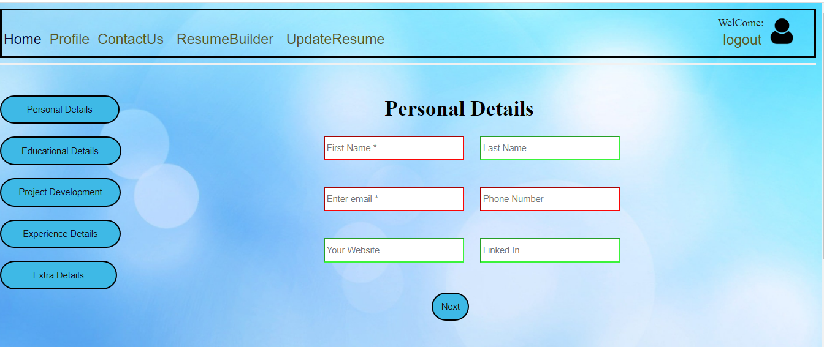

**Fig:** Personal Details

**2 )** Educational Details

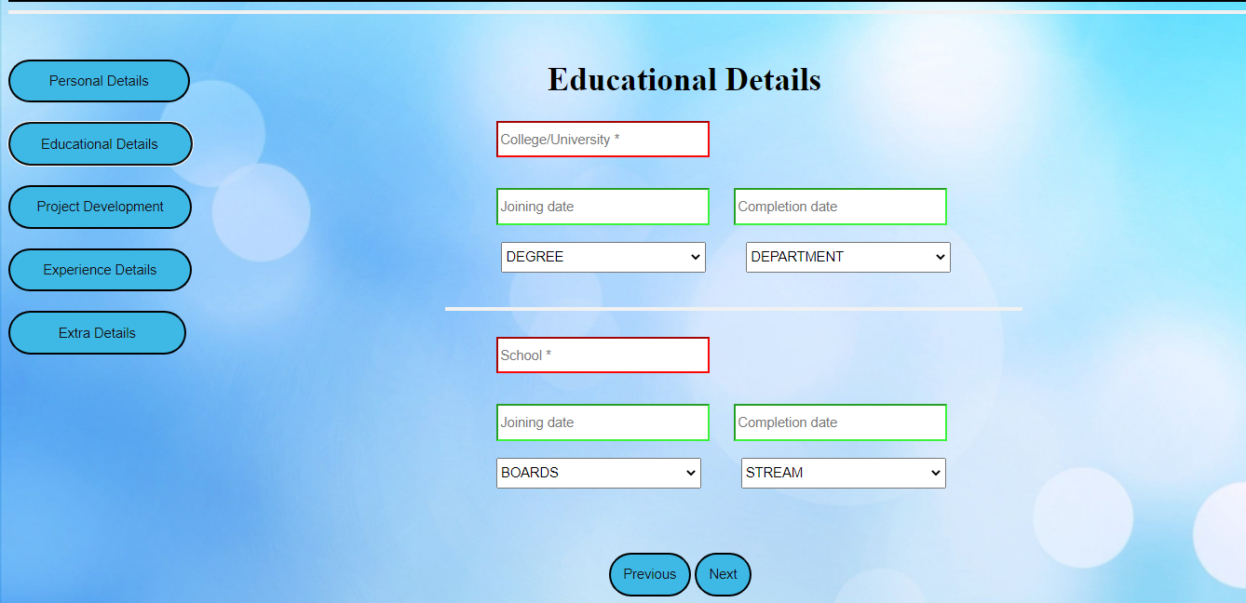

**Fig:** Educational Details

**3 )** Project Development

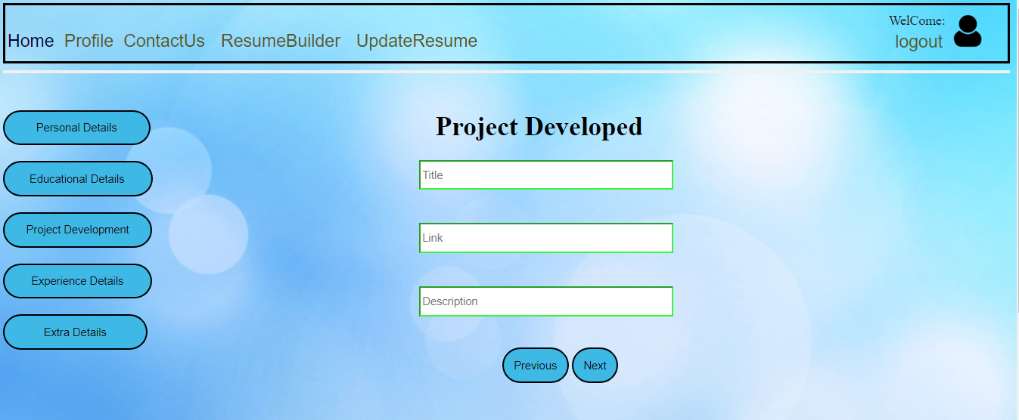

**Fig:** Project Development

**4 )** Experience Details

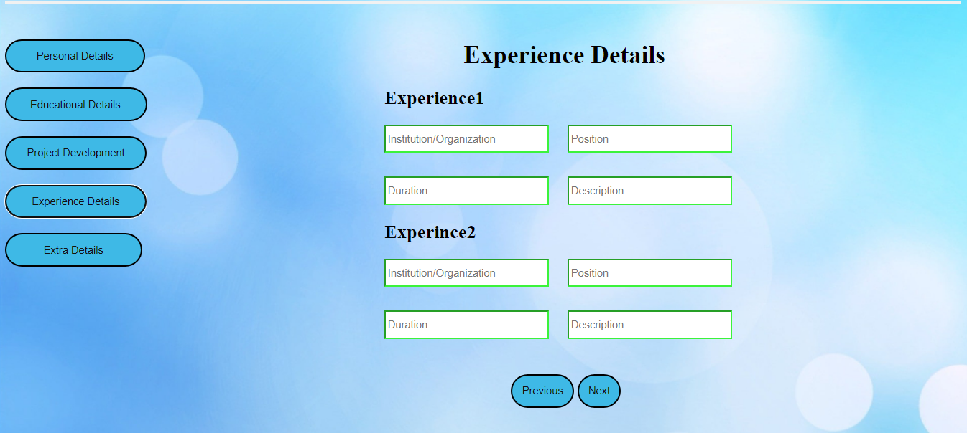

**Fig:** Experience Details

**5 )** Extra Details :

Skills

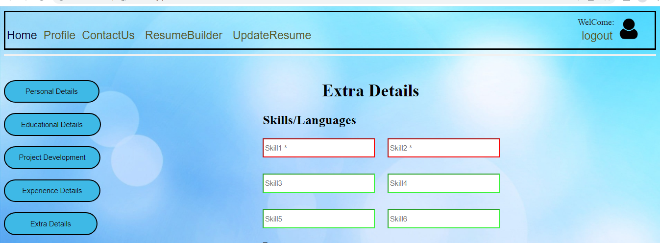

**Fig:** Skills

Interests



**Fig:** Interests

## 10.2 Resume Builder Code:

Resume Builder Jsp code:



Resume Builder DAO code:



Resume Builder Bean code:



Resume Builder Servlet code:



# 11. Resume Updation :

It will preview the resume at first, Where we can download as well as update our resume. In, this we can download the Resume in the PDF format .

## 11.1 Source image:

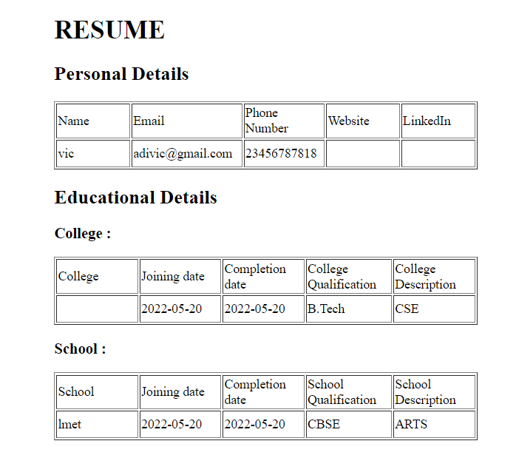

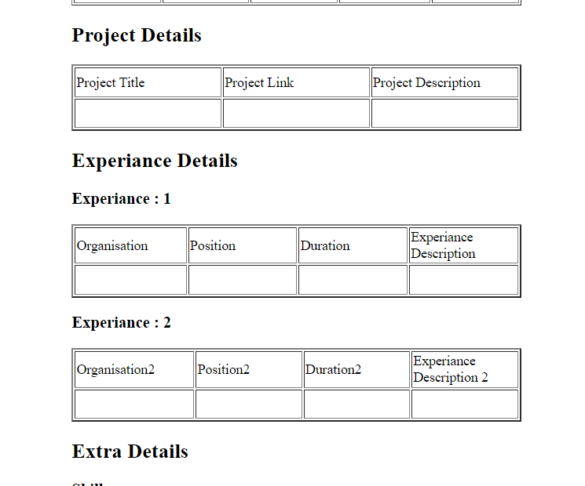

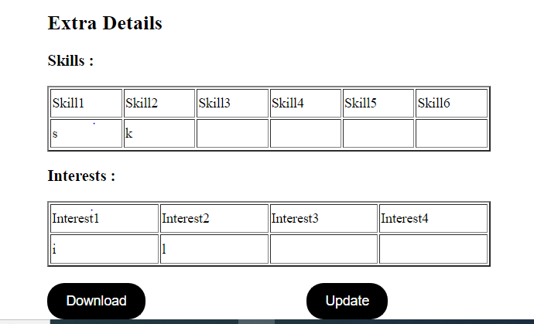

**Fig:** Preview

## 11.2 Resume Download Codes:

Resume Preview code:



Resume Updation code:



# 12. Contact Us :

This is for costumer to contact the company.

## 12.1 Source image:



**Fig:** ContactUs